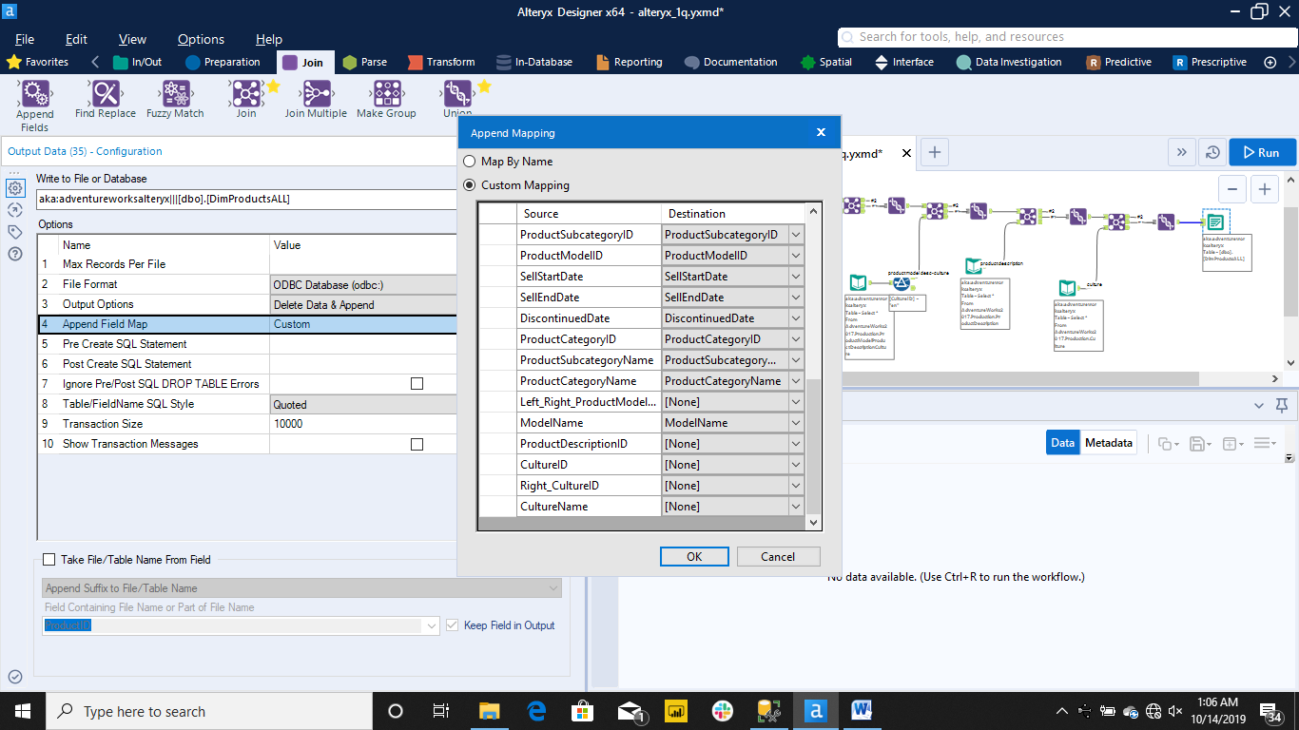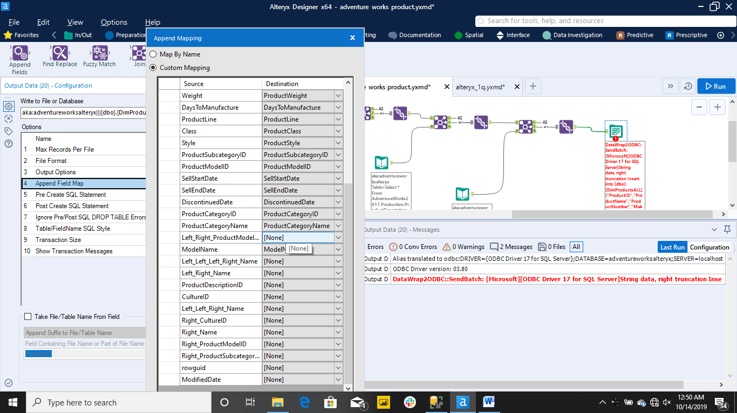

ProductID int NOT NULL, -- ProductNK

ProductNumber varchar(25) NULL, -- ProductAK

ProductName varchar(50) NULL,

ProductSubcategoryID int NULL, -- ProductSubcategoryNK

ProductSubcategoryName varchar(50) NULL,

ProductCategoryID int NULL, -- ProductCategoryNK

ProductCategoryName varchar(50) NULL,

ProductModelID int NULL, -- ProductModelNK

ModelName varchar(50) NULL,

FinishedGoodsFlag int NULL,

MakeFlag int NULL,

StandardCost numeric(15,2) NULL,

ListPrice numeric(15,2) NULL,

DealerPrice numeric(15,2) NULL,

ProductLine char(2) NULL,

ProductClass char(2) NULL,

ProductStyle char(2) NULL,

WeightUnitMeasureCode char(3) NULL,

SizeUnitMeasureCode char(3) NULL,

ProductColor varchar(15) NULL,

SafetyStockLevel int NULL,

ReorderPoint int NULL,

ProductSize varchar(50) NULL,

ProductWeight numeric(15,2) NULL,

DaysToManufacture int NULL,

-- ProductDescription varchar(400) NULL,

SellStartDate date NULL,

SellEndDate date NULL,

DiscontinuedDate date NULL,

SOR_ID int NOT NULL DEFAULT -1,

SOR_LoadDate datetime NULL, -- from SOR

SOR_UpdateDate datetime NULL, -- from SOR

DI_Tool nvarchar(40) NOT NULL default 'what_DI_Tool?',

DI_Job_ID nvarchar(40) NOT NULL default 'no_job_id',

DI_Create_Date datetime NOT NULL default getdate(),

DI_Modified_Date datetime NOT NULL default getdate(),

PRIMARY KEY CLUSTERED (ProductSK)

